Conducting online surveys in China
Bing Mei^{a,b} and Gavin T. L. Brownª
ª Faculty of Education and Social Work, University of Auckland, Private Bag 92019, Auckland 1142, New Zealand
^{b} School of Foreign Languages, Henan University, Kaifeng 475001, China

This is the version accepted as published manuscript
Mei, B., & Brown, G. T. L. (2018). Conducting online surveys in China. Social Science Computer Review, 36(6), 721-734. doi:10.1177/0894439317729340

Abstract
Using online surveys is becoming increasingly extensive and widespread. Social science research in China is no exception. However, due to contextual factors (e.g., technological constraints, social and cultural norms, and language barriers), prior successful methods may not apply. This article reports an alternative way of conducting online surveys in China, by combining local commercial online survey service providers with indigenous Web 2.0 applications. The case study demonstrates the feasibility of this approach and provides practical advice (e.g., adding incentives) on how to effectively conduct online survey in China.

Keywords: online survey; China; research methods; methodology; Web 2.0

Introduction
In an era where information and communication technologies (ICT) have impacted almost all aspects of human society (United Nations Educational, Scientific and Cultural Organization, 2011), there is an increasing prevalence of online surveys (Couper, 2008; Hewson & Laurent, 2008; Sue & Ritter, 2007). This trend is generally attributed to four major advantages of online surveys compared to traditional paper-and-pencil ones: a) larger sample size, b) lower administration costs, c) higher flexibility, and d) greater efficiency (Evans & Mathur, 2005). In recent years, such a shift is further accentuated with the rise of specialised commercial online survey service providers (e.g., SurveyMonkey and Qualtrics) and Web 2.0 technologies (e.g., social networking sites, cloud computing and storage, and mobile devices). These have significantly shaped the design of survey instruments, simplified the dissemination of surveys, improved accuracy in data collection procedures, reduced the workload of data management, and sped up subsequent data analysis (Toepoel, 2016).
However, online surveys in the People’s Republic of China (hereafter China) face an additional potential impediment—the Great Firewall, which controls web content available in China and regulates access to website outside China (Goldkorn, 2012). This means that quick and reliable access to online survey instruments may be a problem for researchers outside China seeking to conduct research in China. The challenge posed by the Great Firewall is particularly the case, when most well-known online survey tools (e.g., Surveymonkey, Qualtrics, and Google Forms) which Western social science researchers frequently use are either unstable or inaccessible in China (Harzing, Reiche, & Pudelko, 2013). The same situation also applies to a large portion of mainstream English-medium Web 2.0 services (e.g., Facebook, Twitter, and Google). Even though these social media services usually have Chinese language versions, their use is restricted to jurisdictions outside the Great Firewall of China (e.g., Taiwan, Singapore, and Hong Kong).
In recent years, with the exponential popularity of ICT in China, there have been unprecedented social movements exploiting technological innovations, such as mobile payment, sharing economy, and Internet of Things (China Internet Network Information Centre [CNNIC], 2017). Concurrently, there are large numbers of postgraduate research students from China in Western universities, some of whom seek to carry out research in China ((Institute of International Education, 2015). More fundamentally, there appears to be a growing interest among all researchers globally about economic, social, psychological, and educational phenomena in China. Given the possibility that many psychological theories and findings are actually not generalizable since they have been developed in Western contexts (Henrich, Heine, & Norenzayan, 2010), there are interesting possibilities to test such findings through online surveying in China. With a population of approximately 1.38 billion (United Nations Department of Economic and Social Affairs Population Division, 2015), no social science researcher should ignore insights from China.
Thus, identifying possible ways of carrying out effective online surveys in China that overcome these structural impediments is important. This article identifies methods of conducting online surveys in China by making use of Web 2.0 resources widely available in the country. It illustrates these resources by describing a case study of online survey hosted on Wenjuan (www.wenjuan.com), a Chinese commercial online survey service provider, with advertisement disseminated via WeChat (www.wechat.com; i.e., Weixin in Chinese), the biggest mobile instant messaging service provided by the Chinese Internet giant—Tencent (www.tencent.com).
The purpose of this report is to share our research experience with other social science researchers who want to conduct online surveys in China by providing information as to possible solutions. First, we provide a concise review of the development of online survey and a brief introduction to the Internet environment in China. Next, we compare several commercial online survey service providers in China. Then we provide details of how we conducted an online survey. Finally, we give some suggestions and recommendations for future research on conducting online surveys in China.
Online surveying
Despite a short history, online surveys have undergone three stages (Dilman, 2007). In the early 1990s, surveys questionnaires were sent out by e-mail systems instead of traditional mail or delivery by hand. This facilitated distribution and data collection processes (Bachmann, Elfrink, & Vazzana, 1996; Chisholm, 1995). Later in the 1990s, with the rapid proliferation of web design technologies, do-it-yourself online surveys began to appear. In this method, respondents were sent an e-mail containing a URL link to the survey webpage, where respondents completed the survey from their desktop computers, with researchers downloading the raw data for offline analysis (e.g., R. P. Baker, 1998; Sippel & Ohmann, 1998; Stanton, 1998). Early in the 21st century, specialised commercial online survey service providers (e.g., SurveyMonkey and Qualtrics) began to thrive. These user-friendly websites greatly lowered the technical thresholds for doing online surveys and provided researchers with handy support in developing standardised questionnaire items, checking data quality, maximizing response rate, and so on (J. D. Baker, 2013; Crawford, 2002; Danielle, Ingrid, & Jonathan, 2013).
A new phase has arisen with the advent of ubiquitous mobile computing (see Couper, 2005). Researchers and commercial online survey service providers are increasingly conducting online surveys in concert with Web 2.0 technologies (e.g., social networking, cloud computing). For example, in a study on recruiting participants through social media, Rife, Cate, Kosinski, and Stillwell (2016) compared data collected from Facebook and a standalone website. Results suggested that no significant differences were detected; therefore, they argued that Facebook could be used as a viable platform to recruit participants and administer questionnaires. In another recent study on Spanish consumers’ online behaviour in the tourism sector, de Rada, Arino, and Blasco (2016) used multiple social media systems to recruit participants. They argued that by engaging multiple platforms, more responses were collected, which thus increased the representativeness of the sample. This is especially important since web-driven recruitment processes generally seem to need twice the sample size to ensure convenience factors in sampling are washed out (Salganik, 2006).
Unsurprisingly, similar practices have mushroomed in China (Lien & Cao, 2014; F. Wang & Sun, 2015; Zhao, Yin, & Song, 2016); however, a search of relevant literature on online survey methodology in the WebSM database (Web Survey Methodology: www.websm.org) suggests that research on how to conduct online surveys in China mainly covers the first three categories (Davison, Li, & Kam, 2006; Sun & Bacon-Shone, 2008; Zhang, Shao, & Fang, 2008). Thus, there is a dearth of information about survey research in China using Web 2.0 tools. It is also likely that social science researchers outside China may not be aware of these alternatives in China.
ICT context in China
China has undergone tremendous economic and social development since Deng Xiaoping’s introduction of capitalist economic practices (Vogel, 2011). It has become the second largest economy, playing an increasingly important role in the world economy (World Bank, 2015); and it is currently the most populous country in the world, with a population of approximately 1.38 billion (United Nations Department of Economic and Social Affairs Population Division, 2015). Since 2006, with an aim to sustain its high-speed social and economic development, ICT has been embraced as a long-term national development strategy by the government (State Council, 2006). As shown in The 40th Statistical Report on Internet Development in China (CNNIC, 2017), by June 2017, there were 751 million Internet users, 724 million mobile Internet users, and 5.06 million websites in China. As of June 2017, 96.3% of the Internet users in China were also mobile Internet users. Smartphone-based Internet applications such as instant messaging, micro blogging, mobile search engines, online video streaming, online shopping, and online education are exerting increasing influence upon Chinese daily life (CNNIC, 2017).
Though great achievements relating to ICT have been made in China, the government has deployed tight and extensive control over the Internet to prevent negative social content or behaviour (pornography, fraud, dissident political ideologies, etc.) being circulated via the Internet (Li, 2008). Besides many regulatory measures by multiple authorities (e.g., Ministry of Information Industry, 2005; Ministry of Public Security, 2005; Office of the Central Leading Group for Cyberspace Affairs, 2016), technological measures have also been in place to monitor the content circulated via the Internet. Though the government has never officially announced its existence, the Great Firewall—a coinage used to allude to the original Great Wall of China which protected the Qin Empire from invasion by barbarians (China Civilisation Centre, 2007)—has been in operation to regulate Chinese access to the Internet outside China (Li, 2008, 2009). Along with the burgeoning ICT, these measures have also exerted significant influence on the overall Internet ecology in China, which is, to a large extent, different from the rest of the world (Kissel, 2007; Larmer, 2011; Liang & Lu, 2010). For example, services from Google, such as Google Search, Gmail, Google forms, and YouTube, are currently inaccessible from China. Other restricted systems include Facebook, Snapchat, and Twitter.
Nonetheless, young people in China are growing up with the Web 2.0 technologies, which provide them with access to an ever-increasing array of flexible applications, portable digital devices, and online resources (CNNIC, 2017). Typical western Web 2.0 interactive and collaborative platforms such as Facebook.com, YouTube.com, Whatsapp.com, and Twitter have been functionally substituted by Chinese-made systems such as Renren.com, Youku.com, WeChat.com, and Weibo.com. Despite lack of access to international platforms, Web 2.0 is exerting great influence upon contemporary Chinese society (see Marolt & Herold, 2014).
Being aware of the growing importance of personal information, the Chinese government has also enacted in recent years several laws that relate to the online collection and storage of personal information data (e.g., Cybersecurity Law, 2016). Generally speaking, apart from collecting sensitive data (e.g., medical records, personal credit information), there is no need, at present, to notify or register with a government authority for conducting online surveys in China. But it is still necessary for researchers to obtain informed, voluntary consent from any participant, inform them of the research purpose, and ensure that the collected data is kept secure, confidential, and used only for the specified purpose (Dong & He, 2016).

Commercial Online Survey Service Providers in China
With the burgeoning development of the Internet in China, many local commercial online survey websites are currently available for research purposes in China. Here we focus on three popular ones, which have been frequently used by social science researchers in China. These platforms include Sojump (e.g, Lien, Cao, & Zhou, 2017; Yang, Chen, Zhang, Wang, & Ding, 2016;), Diaoyanbao (e.g., Liu, Shi, Liu, & Zhang, 2014; S. Wang, Wu, & Zhou, 2016), and Wenjuan (e.g., Zhang, 2016; Zhao et al., 2016). Table 1 lists the main features and functions of these three local commercial survey platforms and compares them with two Western ones—Surveymonkey and Qualtrics. As is shown in Table 1, similar to their Western counterparts, all three local ones provide (a) templates to speed the design of questionnaires, (b) compatibility to link with social media, (c) options to distribute incentives, and (d) support to recruit participants. Furthermore, collected data can also be exported in common file formats such as csv, txt, pdf, xls, and sav. Hence, there is no shortage of online surveying tools in China. Considering its flexible pricing options and practical functionality, this study adopted Wenjuan as an exemplar platform.

Table 1. Comparison of Some Commercial Online Survey Service Providers

Survey platforms | Template availability | Social media compatibility | Incentive options | Sample recruitment services | Pricing options ª | Prominent clients
Local platforms
Sojump | Yes | Yes | Yes | Yes | Free, monthly/annual subscription | Peking University, Shanghai Jiaotong University
Diaoyanbao | Yes | Yes | Yes | Yes | Free, quote-based | Air China, China Eastern, HSBC
Wenjuan | Yes | Yes | Yes | Yes | Free, annual subscription, quote-based | Tsinghua University, China Telecom, Lenovo
Western platforms
SurveyMonkey | Yes | Yes | Yes | Yes | Free, monthly/annual subscription | Microsoft, Samsung, Facebook
Qualtrics | Yes | Yes | Yes | Yes | Annual Subscription, quote-based | eBay, FedEx, Spotify
Note. ª Though most survey platforms do offer free versions, their functionality is usually limited.

Case Study of an Online Survey in China
Digital Procedures
Although surveying tools may exist in China, this does not automatically mean researchers outside China know how to operate these systems. In this section, we describe how we developed and delivered an online survey in a provincial city of China. The questionnaire was designed to identify factors influencing Chinese pre-service teachers’ intention to use Web 2.0-based technologies for language learning purposes (Mei, Brown, & Teo, 2017).
Before the online survey was implemented, a pilot test on the accessibility of SurveyMonkey and Qualtrics was conducted in three different inland cities in China (i.e., Beijing, Chongqing, and Kaifeng) using multiple cross-platform devices in January 2016. Although SurveyMonkey webpages could be loaded, the speed of opening was highly variable. Further, the dissemination and incentive options provided by SurveyMonkey were limited. As for Qualtrics, the pages were inaccessible, possibly because of the Great Firewall. Therefore, in both cases, the results were below expectations, potentially impacting user experiences and threatening the quality of the survey data.
Considering the intended population of the survey were university students, Wenjuan was deemed the most appropriate choice for the online survey because it had a free version and because it allowed distribution of virtual cash incentives through WeChat, a versatile and highly popular instant messaging application among university students.
The basic free version provided by Wenjuan has no response limits, that is, no limits have been set to restrict the number of questionnaires, participants, or the data to be exported. In addition, it supports draft questionnaire export, encrypts the collected data, and previews a questionnaire on multiple devices by scanning a quick response (QR) code. However, some advanced feathers (adding in logos, distributing incentives, and using custom domains, etc.) need to be purchased, but these could be arranged according to researchers’ needs. Compared with its western counterparts, a big advantage of Wenjuan is that it provides a practical solution of combining online survey with local Web 2.0 services. The questionnaires hosted by Wenjuan can be directly sent out through WeChat, with virtual cash incentives attached as red packets, which contains virtual cash transferrable to participants’ WeChat wallets, thus keeping participants motivated to complete a survey. During the process, instead of immediately directing participants to the survey page in the application, WeChat users were asked to allow Wenjuan to access and collect personal public information such as WeChat ID and Geolocation (Tencent, 2017).

In March 2016, pre-service EFL teachers from a university in China were invited to the survey. The QR code and URL link were sent by an administrative staff member, who had access to the public WeChat discussion groups set up by the school administration for notification purposes. By scanning the QR code or clicking the URL link, participants were directed to an institutional ethics review board approved on-line questionnaire survey hosted by Wenjuan within WeChat. This arrangement was feasible because of the high penetration rate of smart phones and online applications in China, especially among university-age students (CNNIC, 2017).
As the survey was carried out just after the Chinese New Year—Spring Festival, each participant completing the survey received a WeChat red packet of 5 Chinese Yuan (5 CNY ≈ 0.80 USD) as a token of appreciation. Red packets (also known as lucky money or red envelope) are distributed at Chinese New Year to young people, and WeChat provides a digital red packet system to deliver virtual cash as an indicator of cheerful generosity associated with actual red packet giving. Considering the budget and power of the subsequent statistical analysis, the upper limit of total responses was set at 500. Furthermore, two respondents were invited to test the red packet distribution; no technical problems were detected in the pilot tests.
Within one day, the pre-set target was achieved. A total of 498 unique respondents participated via WeChat installed on their smart devices. The average time taken to complete the survey of 42 questions was four minutes and 17 seconds with a standard deviation of one minute 51 seconds. Altogether, 2,788 unique WeChat users visited the survey webpage while it was open to the public. IP addresses of submitted questionnaires were recorded and checked to remove respondents from regions outside the intended scope of the survey. This step produced a final retained sample of 440 respondents. Please see Appendix for more detailed information about the procedures.

Discussion
In an increasingly digitised world, the use of online surveys for social science research is expected to become the norm (Denscombe, 2006; Toepoel, 2016). Specialised commercial online survey service providers coupled with Web 2.0 technologies have afforded researchers unprecedented opportunities to realise online surveys (de Rada et al., 2016; Rife et al., 2016). However, there are significant challenges for researchers outside of China to conduct online surveys in that country. This article has overviewed resources and challenges in China and exemplified how online surveys can be done in contemporary China by combining local service providers and local Web 2.0 services. It is hoped that the experience will help Western researchers to extend their research into the large population of China.
It is important to bear in mind the demographics of potential respondents in a survey to avoid coverage error (Toepoel, 2016). Our own online survey was aimed at younger urban people in China. Local Web 2.0 services such as Weibo and WeChat may be convenient in recruiting such participants, but they may also result in biased sampling since such respondents tend to be young and technologically savvy. Research involving senior citizens may be unsuccessful if they have to be answered on smartphone devices due to the small size of the screen and challenges caused by uncorrected fading eyesight. Similarly, it may be also unrealistic for a study on participants from impoverished rural areas to be conducted this way because they may have little or no access to devices or the Internet. Thus, careful attention to the characteristics of different populations is needed in designing online surveys in China.
Previous reports suggest that embedding multimedia content could boost participants’ willingness to complete survey (Mendelson, Gibson, & Romano-Bergstrom, 2016). Nevertheless, contextual factors such as speed of the Internet, high cost of cellular data, and technical ramifications (e.g., advertisements pushed by hosting streaming sites) decrease the practicality of using multimedia content. Therefore, multimedia content should be used with caution.
Internet users in China have long been harassed with rampant Internet fraud and privacy leakage (Kshetri, 2013). Thus, besides those previously identified factors increasing participants’ willingness to complete mobile surveys (e.g., Bosnjak, Metzger, & Gräf, 2009), extra care needs to be taken to ensure that private data is fully protected. This may be a reason to prefer a Western survey system rather than rely on a China survey provider. Until full data protection can be assured, including safety from state inspection, online surveys should perhaps restrict their content to politically safe topics and not seek any high-risk personal or economic data.
As for the use of incentives, our results resonated with prior findings as to the positive effect of adding a small cash incentive to online surveys (Birnholtz, Horn, Finholt, & Bae, 2004; Göritz, 2006; Pedersen & Nielsen, 2016; Ryu, Couper, & Marans, 2006). The immediate virtual cash incentives distribution via WeChat also proved to be an effective way of motivating respondents to complete online surveys to avoid a high abandoning rate associated with mobile devices (Bosnjak & Tuten, 2003; Poggio, Bosnjak, & Weyandt, 2015).
With the release of new cybersecurity law in China, it is of critical significance to gain participants’ consent before collecting their personal data. In this sense, coupling third party survey platforms with WeChat in tandem seems a viable way to seek participants’ preliminary permission for collecting personal information stored in WeChat (Tencent, 2015).
However, conveniences do come with limitations. First, though links were sent to a closed WeChat discussion group, participants may forward the link to others, especially for the reward of virtual cash. This may affect the quality and reliability of the survey. Therefore, measures (e.g., IP address check and limited survey time frame) should be prepared in advance. In this survey, since all participants were from the same area, pertinent IP address checking measures were taken, so as to exclude responses from other regions from analysis and incentives. Additionally, because most participants completed the online survey on mobile devices, the questionnaire design had to be appropriate to the capacities of such tools. This may limit some studies, which cannot easily fit into small screens. Furthermore, though mobile-friendly layout (e.g., using accordion format for matrix tables) could reduce the total time spent in completing the questionnaire on their mobile devices, it is likely that some respondents might just complete as quickly as possible to get the virtual cash incentive. Future studies are needed to find possible measures to minimise this threat. Last but not least, though a sample recruitment service was available, it was not used in this study. Future research is needed as to the efficacy and validity of sample panels available through China’s online survey systems. The representativeness and reliability of online survey panels and random sampling through WeChat also needs to be established.
Thanks to the rapid proliferation of ICT, there exist a wide range of alternatives besides the example we provide that combined Wenjuan and WeChat. Researchers may find different platforms such as Weibo, QQ, or Sojump, to provide useful alternatives. Given that, future research should ascertain how smartphone users respond to online surveys as opposed to those using larger computer screens. Research into online surveying in China needs to investigate the effects of different question types, questionnaire designs, and virtual cash incentives (mobile top-up, red packet, lottery draw, etc.). Given the exponential growth of WeChat, its role and potential in facilitating online surveys should be further investigated not only in the Greater China region but also among overseas Chinese.
This brief report demonstrates that online surveying in China is completely feasible, although some extra care may need to be exercised. Western researchers do have effective solutions for the problems created by China’s Internet self-protection. China’s great adoption of digital ICT and Web 2.0 facilities means that online surveying is a powerful and realistic solution to collecting data in China.
Author Information

Bing Mei
Faculty of Education and Social Works, University of Auckland
Private Bag 92019
Auckland 1142
New Zealand
Telephone: +64-(0)9-623-8899 ext. 48153

Email: bmei560@aucklanduni.ac.nz
Bing Mei is a Project Assistant in the Digital Learning Team, Faculty of Education and Social Work, University of Auckland, and a lecturer at Henan University. His research interests include computer-assisted language learning, technology acceptance, online surveys, and teacher education.

Gavin T. L. Brown
Email: gt.brown.@auckland.ac.nz
Gavin T. L. Brown is Professor and Director of the Quantitative Data Analysis and Research Unit in the Faculty of Education and Social Work, University of Auckland. His research focus is on school-based assessment, informed by psychometric theory, with a special focus on the social psychology of people’s responses to educational assessment. He is an expert in confirmatory factor analysis and structural equation modeling.
References
Bachmann, D., Elfrink, J., & Vazzana, G. (1996). Tracking the progress of e-mail versus snail-mail. Marketing Research, 8(2), 31–35.
Baker, J. D. (2013). Online survey software. In M. Bocarnea, R. Reynolds, & J. Baker (Eds.), Online instruments, data collection, and electronic measurements: Organizational advancements (pp. 328–334). Hershey, PA.: Information Science Reference.
Baker, R. P. (1998). Computer assisted survey information collection. Hoboken, NJ: John Wiley & Sons.
Birnholtz, J. P., Horn, D. B., Finholt, T. A., & Bae, S. J. (2004). The effects of cash, electronic, and paper gift certificates as respondent incentives for a Web-based survey of technologically sophisticated respondents. Social Science Computer Review, 22(3), 355–362.
Bosnjak, M., Metzger, G., & Gräf, L. (2009). Understanding the willingness to participate in mobile surveys: Exploring the role of utilitarian, affective, hedonic, social, self-expressive, and trust-related factors. Social Science Computer Review, 28(3), 350–370.
Bosnjak, M., & Tuten, T. L. (2003). Prepaid and promised incentives in web surveys. Social Science Computer Review, 21(2), 208–217.
China Civilisation Centre. (2007). China: Five thousand years of history and civilization. Hong Kong: City University of Hong Kong Press.
Chisholm, J. (1995). Surveys by e-mail and Internet. Unix Review, 13, 11–16.
CNNIC (China Internet Network Information Centre). (2017). The 40th statistical report on China Internet development. Retrieved from http://www.cnnic.cn/hlwfzyj/hlwxzbg/hlwtjbg/201708/P020170803598956435591.pdf
Couper, M. P. (2005). Technology trends in survey data collection. Social Science Computer Review, 23(4), 486–501.
Couper, M. P. (2008). Designing effective web surveys (Vol. 75): Cambridge University Press New York, NY.
Crawford, S. (2002). Evaluation of web survey data collection systems. Field Methods, 14(3), 307–321.
Cybersecurity Law. (2016). Retrieved from http://www.npc.gov.cn/npc/xinwen/2016-11/07/content_2001605.htm
Danielle, A. B., Ingrid, B.-J., & Jonathan, C. (2013). Developing and completing a library mobile technology survey to create a user-centered mobile presence. Library Hi Tech, 31(4), 688–699.
Davison, R. M., Li, Y., & Kam, C. S. (2006). Web-based data collection in China. Journal of Global Information Management, 14(3), 39–58.
de Rada, V. D., Arino, L. V. C., & Blasco, M. G. (2016). The use of online social networks as a promotional tool for self-administered internet surveys. Revista Espanola de Investigaciones Sociologicas, 25(2), 189–203.
Denscombe, M. (2006). Web-Based Questionnaires and the Mode Effect. Social Science Computer Review, 24(2), 246–254.
Dilman, D. A. (2007). Mail and internet surveys: The tailored design method 2007 update with new internet, visual, and mixed-mode guide. Hoboken, NJ: Johan Wiley & Sons.
Dong, X., & He, J. (2016). Data protection in China: Overview. Retrieved from https://uk.practicallaw.thomsonreuters.com/4-519-9017?transitionType=Default&contextData=(sc.Default)&firstPage=true&bhcp=1
Evans, J. R., & Mathur, A. (2005). The value of online surveys. Internet Research, 15(2), 195–219.
Goldkorn, J. (2012). Behind the Great Firewall. In G. R. Barmé (Ed.), Red rising red eclipse: China story year book 2012 (pp. 170–193). Canberra: Australian Centre on China in the World.
Göritz, A. S. (2006). Incentives in web studies: Methodological issues and a review. International Journal of Internet Science, 1(1), 58–70.
Harzing, A.-W., Reiche, B. S., & Pudelko, M. (2013). Challenges in international survey research: a review with illustrations and suggested solutions for best practice. European Journal of International Management, 7(1), 112–134.
Henrich, J., Heine, S. J., & Norenzayan, A. (2010). The weirdest people in the world? Behavioral and Brain Sciences, 33(2/3), 61-135. doi:10.1017/S0140525X0999152X
Hewson, C., & Laurent, D. (Eds.). (2008). SAGE handbook of online research methods. Thousand Oaks, CA: SAGE.
Kissel, T. (2007). License to blog: Internet regulation in the People's Republic of China. Indiana International Comparative Law Review, 17(1), 229–268.
Kshetri, N. (2013). Cybercrime and cyber-security issues associated with China: some economic and institutional considerations. Electronic Commerce Research, 13(1), 41–69.
Larmer, B. (2011). Where an Internet joke is not a joke. Retrieved from http://www.nytimes.com/2011/10/30/magazine/the-dangerous-politics-of-internet-humor-in-china.html.
Li, Y. (2008). The Great Firewall: The logic of China's administration. 21st Century, 4(106), 70–87.
Li, Y. (2009). Our Great Firewall: Expression and governance in the era of the Internet. Guilin: Guangxi Normal University Press.
Liang, B., & Lu, H. (2010). Internet development, censorship, and cyber-crimes in China. Journal of Contemporary Criminal Justice, 26(1), 103–120.
Lien, C. H., & Cao, Y. (2014). Examining WeChat users’ motivations, trust, attitudes, and positive word-of-mouth: Evidence from China. Computers in Human Behavior, 41, 104–111.
Lien, C.-H., Cao, Y., & Zhou, X. (2017). Service quality, satisfaction, stickiness, and usage intentions: An exploratory evaluation in the context of WeChat services. Computers in Human Behavior, 68, 403-410.
Liu, X., Shi, W., Liu, W., & Zhang, Y. (2014). Survey of learning demands on nursing professional practice network courses. Chinese Nursing Research, 28(8), 2990–2991
Marolt, P., & Herold, D. K. (Eds.). (2014). China online: Locating society in online spaces. New York: Routledge.
Mei, B. (2016). Towards an Understanding of Mainland Chinese Pre-Service EFL Teachers’ Intention to Use CALL 2.0. (unpublished doctoral thesis). The University of Auckland, Auckland, NZ.
Mei, B., Brown, G. T. L., & Teo, T. (2017). Towards an understanding of pre-service EFL teachers’ acceptance of CALL 2.0 in the PRC. Journal of Educational Computing Research, 1–31. Doi:10.1177/0735633117700144
Mendelson, J., Gibson, J. L., & Romano-Bergstrom, J. (2016). Displaying videos in web surveys: Implications for complete viewing and survey responses. Social Science Computer Review. Advanced online publication. doi:10.1177/0894439316662439
Ministry of Information Industry. (2005). Fei jingyingxing hulianwang xinxi fuwu beian guanli fangfa [Registration administration measures for non-commercial Internet information services]. Retrieved from http://www.miitbeian.gov.cn/state/outPortal/queryMutualityDownloadInfo.action?id=11.
Ministry of Public Security. (2005). Hulianwang anquan baohu jishu cuoshi guiding [Provisions on Internet security protection technology measures]. Retrieved from http://www.gov.cn/gongbao/content/2006/content_421771.htm.
Office of the Central Leading Group for Cyberspace Affairs. (2016). Guanyu jiaqiang guojia wangluo anquan biaozhunhua gongzuode ruogan yijian [Opinions on how to standardize and strengthen cybersecurity]. Retrieved from http://www.cac.gov.cn/2016-08/22/c_1119430337.htm.
Pedersen, M. J., & Nielsen, C. V. (2016). Improving survey response rates in online panels: Effects of low-cost incentives and cost-free text appeal interventions. Social Science Computer Review, 34(2), 229–243. doi:10.1177/0894439314563916
Poggio, T., Bosnjak, M., & Weyandt, K. (2015). Survey participation via mobile devices in a probability-based online-panel: Prevalence, determinants, and implications for nonresponse. Survey Practice, 8(2), 1–7.
Rife, S. C., Cate, K. L., Kosinski, M., & Stillwell, D. (2016). Participant recruitment and data collection through Facebook: the role of personality factors. International Journal of Social Research Methodology, 19(1), 69–83. doi:10.1080/13645579.2014.957069
Ryu, E., Couper, M. P., & Marans, R. W. (2006). Survey incentives: Cash vs. in-kind; face-to-face vs. mail; response rate vs. nonresponse error. International Journal of Public Opinion Research, 18(1), 89–106.
Salganik, M. J. (2006). Variance estimation, design effects, and sample size calculations for respondent-driven sampling. Journal of Urban Health, 83(1), 98–112.
Sippel, H., & Ohmann, C. (1998). A web-based data collection system for clinical studies using Java. Medical Informatics, 23(3), 223–229.
Stanton, J. M. (1998). An empirical assessment of data collection using the Internet. Personnel Psychology, 51(3), 709–725.
State Council. (2006). 2006–2020 nian guojia xinxihua fazhan zhanlue [The 2006–2020 national informatization development strategy]. Retrieved from http://www.gov.cn/gongbao/content/2006/content_315999.htm.
Sue, V. M., & Ritter, L. A. (Eds.). (2007). Conducting online surveys. Thousand Oaks, CA: SAGE.
Sun, X., & Bacon-Shone, J. (2008). Mobile phone survey methodology in China. Paper presented at the Joint Statistical Meetings 2008, Denver, USA, August 3–7, 2008.
Tencent. (2015). WeChat: Privacy policy. Retrived from https://www.wechat.com/en/privacy_policy.html
Tencent. (2017). Weixin gongzhong pingtai jishu wendang [WeChat public account developer documentation]. Retrieved from https://mp.weixin.qq.com/wiki
Toepoel, V. (2016). Doing surveys online. Thousand Oaks, CA: SAGE.
United Nations Department of Economic and Social Affairs Population Division. (2015). World population prospects: The 2015 revision. Retrieved from https://esa.un.org/unpd/wpp/publications/files/key_findings_wpp_2015.pdf.
United Nations Educational Scientific and Cultural Organization. (2011). Transforming education: The power of ICT policies. Paris: Author.
Vogel, E. F. (2011). Deng Xiaoping and the Transformation of China. Cambridge, MA: Belknap Press.
Wang, F., & Sun, X. (2015). Absolute power leads to absolute corruption? Impact of power on corruption depending on the concepts of power one holds. European Journal of Social Psychology, 46, 77–89.
Wang, S., Wu, W., & Zhou, X. (2016). App store analysis: Using regression model for app downloads prediction. In W. Che, Q. Han, H. Wang, W. Jing, S. Peng, J. Lin, G. Sun, X. Song, H. Song, & Z. Lu (Eds.), Social Computing: Second International Conference of Young Computer Scientists, Engineers and Educators (pp. 206–220). Singapore: Springer Singapore.
World Bank. (2015). World development report 2015: Mind, society, and behavior. Retrieved from http://www.worldbank.org/content/dam/Worldbank/Publications/WDR/WDR 2015/WDR-2015-Full-Report.pdf.
Yang, Z., Chen, H., Zhang, X., Wang, R., & Ding, J. (2016). The online version of the Chinese intolerance of uncertainty scale: Psychometric properties. Cyberpsychology, Behavior, and Social Networking, 19(3), 217–222.
Zhang, Q., Shao, P., & Fang, J. (2008). Bibliometric analysis of current web survey research in China. Tsinghua Science and Technology, 13(3), 420–424.
Zhang, S. (2016). Mobile English learning: An empirical study on an App, English fun dubbing. International Journal of Emerging Technologies in Learning, 11(12), 4–8.
Zhao, L., Yin, J., & Song, Y. (2016). An exploration of rumor combating behavior on social media in the context of social crises. Computers in Human Behavior, 58, 25–36.

Appendix

Conducting an Online Survey with Wenjuan

Survey Creation

Step 1: Sign up for a free plan by Wenjuan.

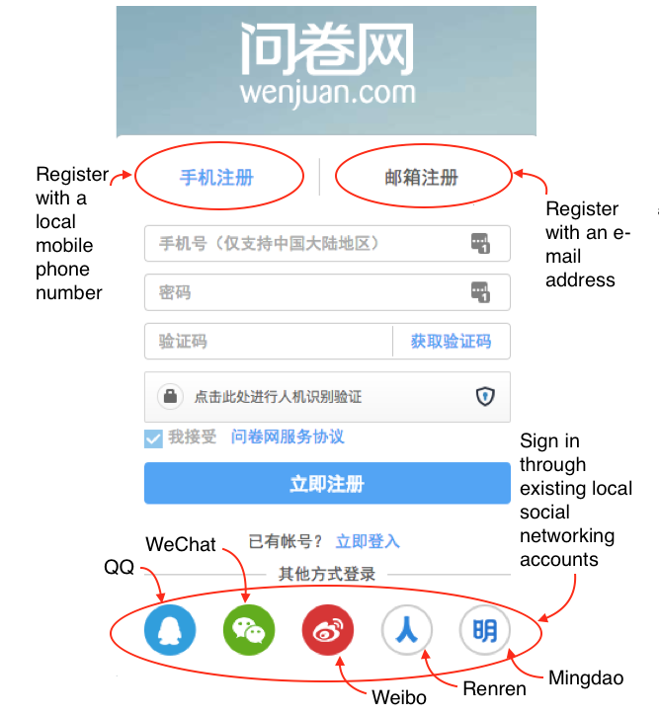
- Preferably, register with a Chinese e-mail address, existing social networking accounts (including QQ, WeChat, Weibo, Renren, and Mingdao), or mobile phone numbers to avoid possible technical difficulties with the Great FireWall (e.g., unable to receive verification or password reset e-mails/messages in time).

Step 2: Add and edit survey questions.
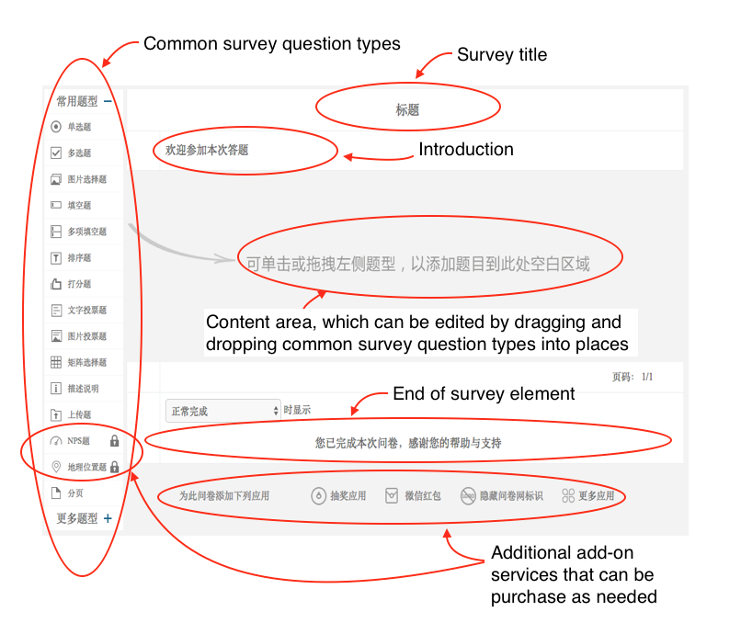

- Twenty-five commonly used survey question types (e.g., multiple choices, matrix table, rank order, and text entry) are available in free plan offered by Wenjuan. In addition, researchers can also compile their own questionnaires on the basis of existing survey templates included in the open library of Wenjuan.
- After entering all survey questions, add-on incentive/branding services can be purchased as needed. Alternatively, all features become available by subscribing to an annual plan (CN¥ 1,999 per year). These include:
  - Set up an automatic prize drawing,
  - Design number and amount of incentives (i.e., red packets distributed through WeChat),
  - Remove the default logo and use custom logo, and
  - Use custom domain names.
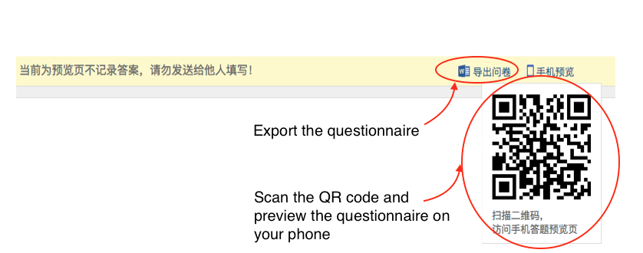
- Additionally, when in the Preview mode, the draft questionnaire can be exported as a Word document file for proofreading or for printing as an offline paper-and-pencil survey.

Step 3: Customise survey settings.
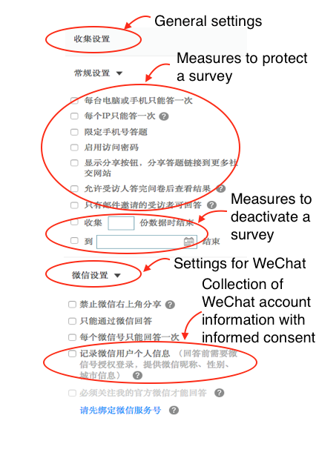
- The flexibility afforded by Wenjuan allows you multiple options to protect a survey (e.g., preventing participants from taking the survey more than once or setting a survey password) or deactivate it under contain conditions (e.g., reaching a specific response number or a specific date), and collect certain information from respondents (e.g., IP addresses and WeChat account information).
- Wenjuan employs Transport Layer Security (TLS) encryption (i.e., HTTPS) to ensure the sercurity of data transmission process. Moreover, automated data backup and intrusion prevention systems are also deployed for secure data storage.

Distribution and Data Collection
Step 4: Deliver the questionnaire to the potential participants.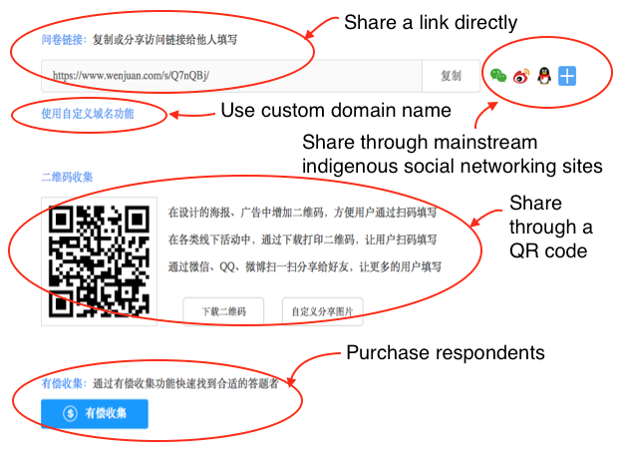

- If you have access to the target population, the link to a survey and can be sent directly through multiple channels (e.g., WeChat, Weibo, QQ, e-mails, or Web links).
- In case you have no access to the target population in China, respondents can be purchased from Wenjuan. The sampling process is based on the information provided in their profiles. The pricing varies according to the number of completed responses, the length of the survey, geographic location, and three demographic conditions of required participants (i.e., gender, age, and marital status).

Data Export
Step 5: Data download.
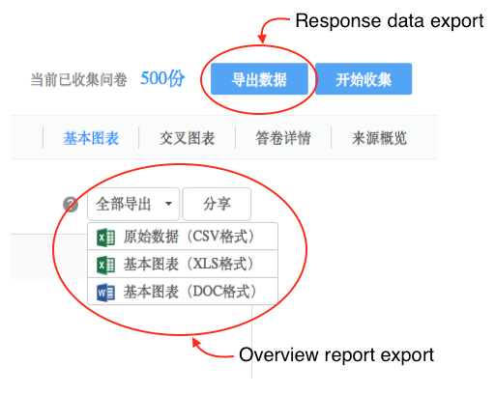
- Wenjuan allows direct export of survey response data as CSV files.
- Overview reports are also available to download as CSV, Excel workbook, or Word document files.

